ht2383 N15040025 Hua Wen, Tsuei

Project2 report

Part1:

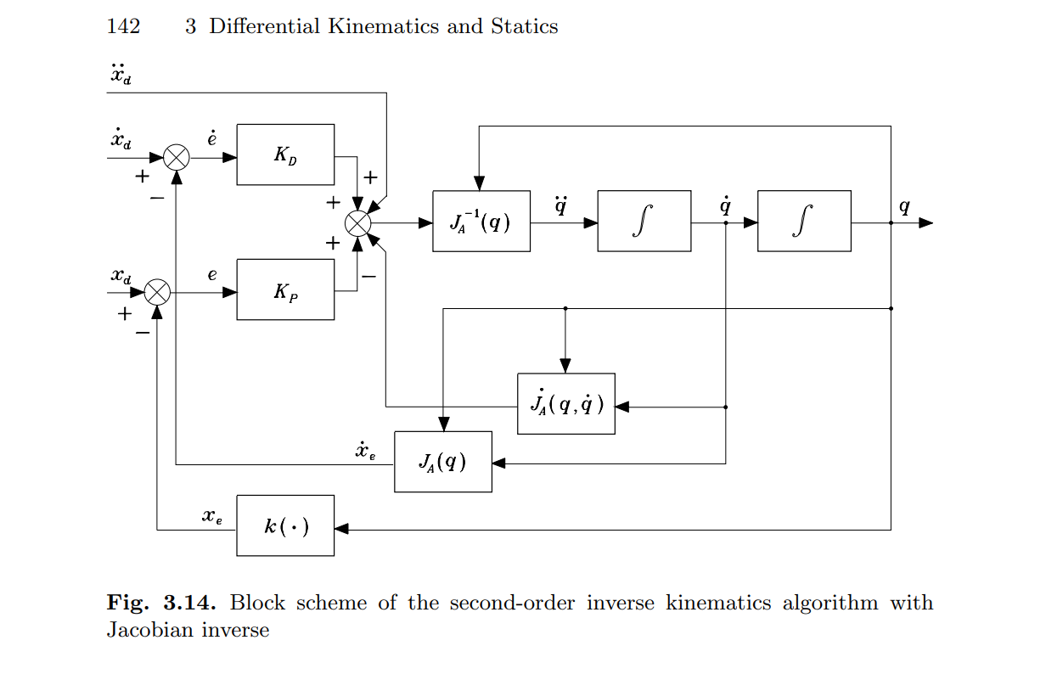

According to the scheme on textbook, I draw the same structure on matlab using Simulink.(run the init.m file)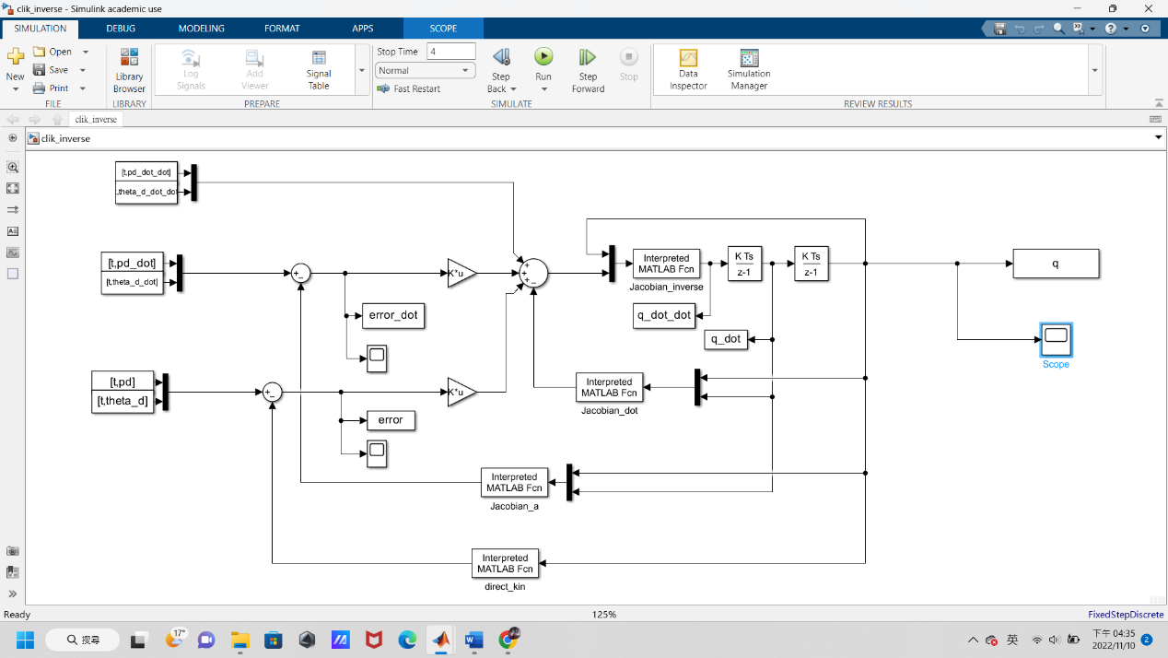

For KD KP I set them both 300.

Put scope on e, e_dot & q to observe

the scope of q:

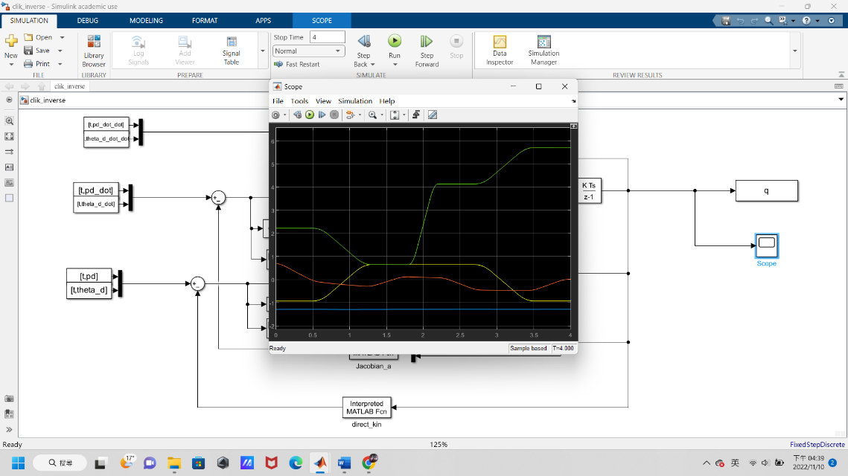

the scope of error:

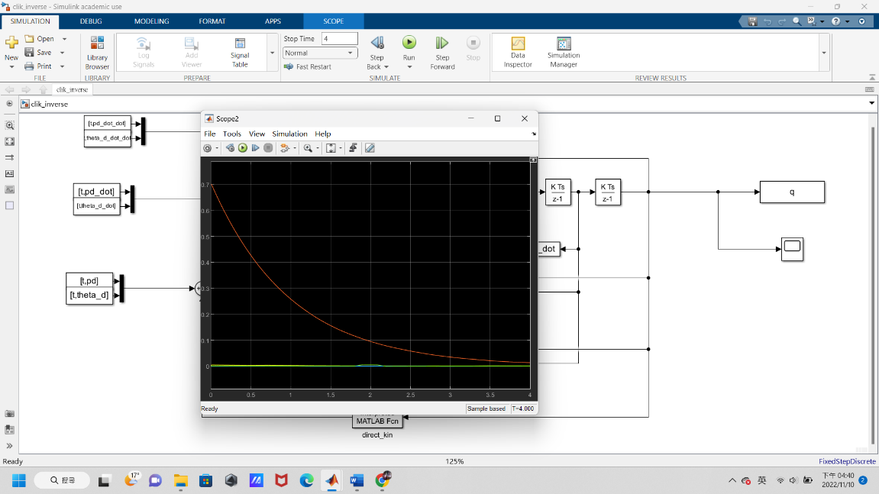

the scope of error_dot:

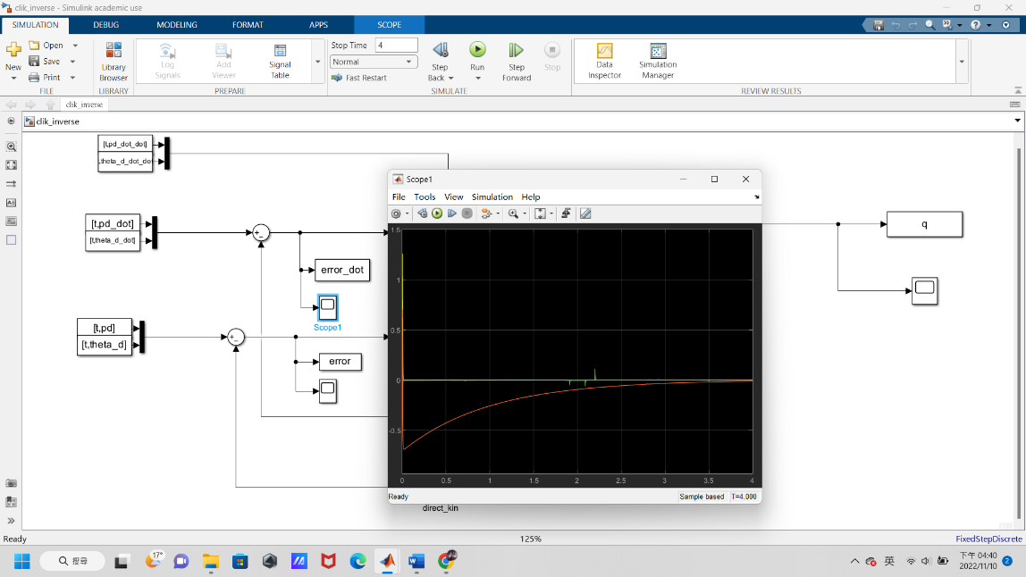

Analytic Jacobian:

-a1*sin(th1)-a2*sin(th1+th2) -a2*sin(th1+th2) 0 0

a1*cos(th1)+a2*cos(th1+th2) a2*cos(th1+th2) 0 0

0 0 -1 0

1 1 0 -1

Jacobian inverse:

-a1*sin(th1)-a2*sin(th1+th2) -a2*sin(th1+th2) 0 0

a1*cos(th1)+a2*cos(th1+th2) a2*cos(th1+th2) 0 0

0 0 -1 0

1 1 0 -1

Jacobian dot:

-a1*sin(th1)-a2*sin(th1+th2) -a2*sin(th1+th2) 0 0

a1*cos(th1)+a2*cos(th1+th2) a2*cos(th1+th2) 0 0

0 0 -1 0

1 1 0 -1

If you run the plot_output.m file you will get all the Joint value and Operational space Error.

Operational space Error:

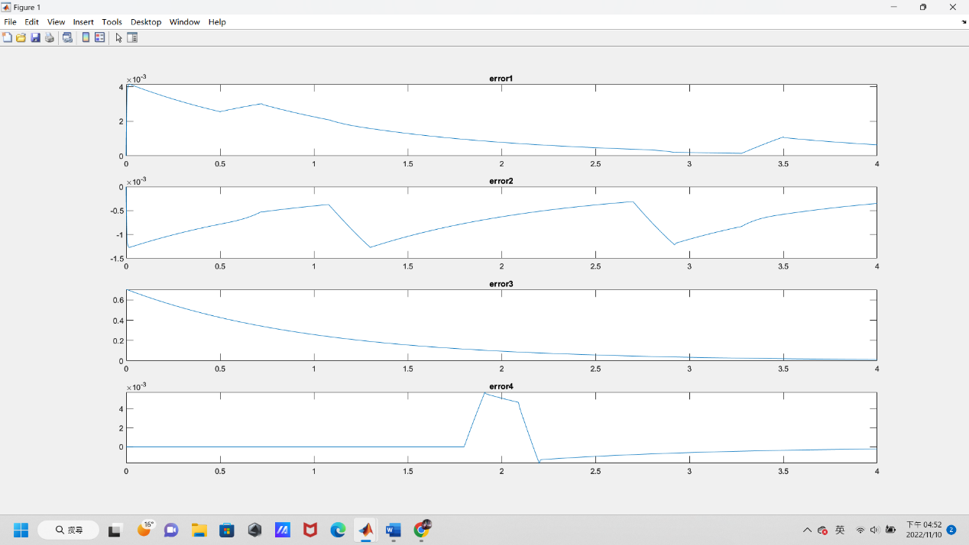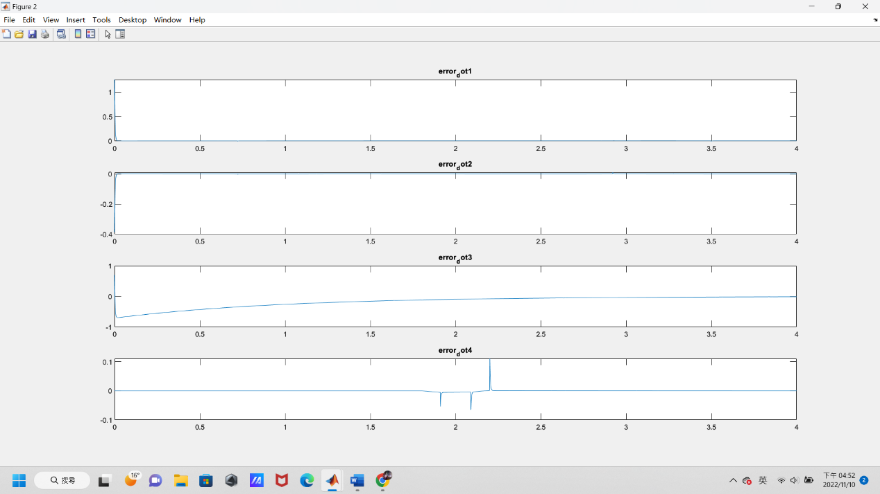

Joint value: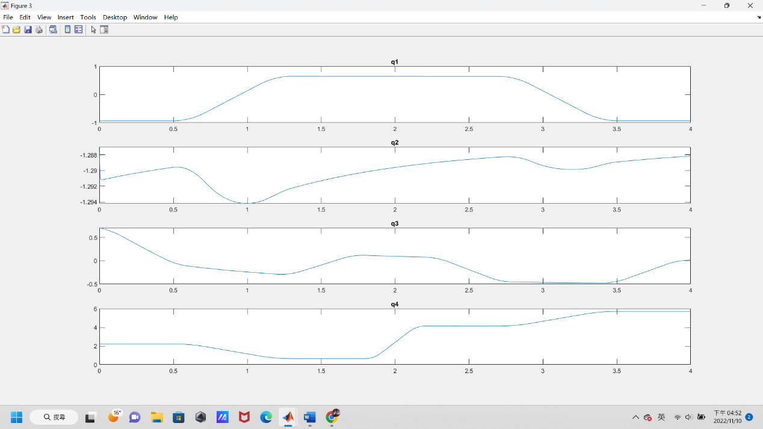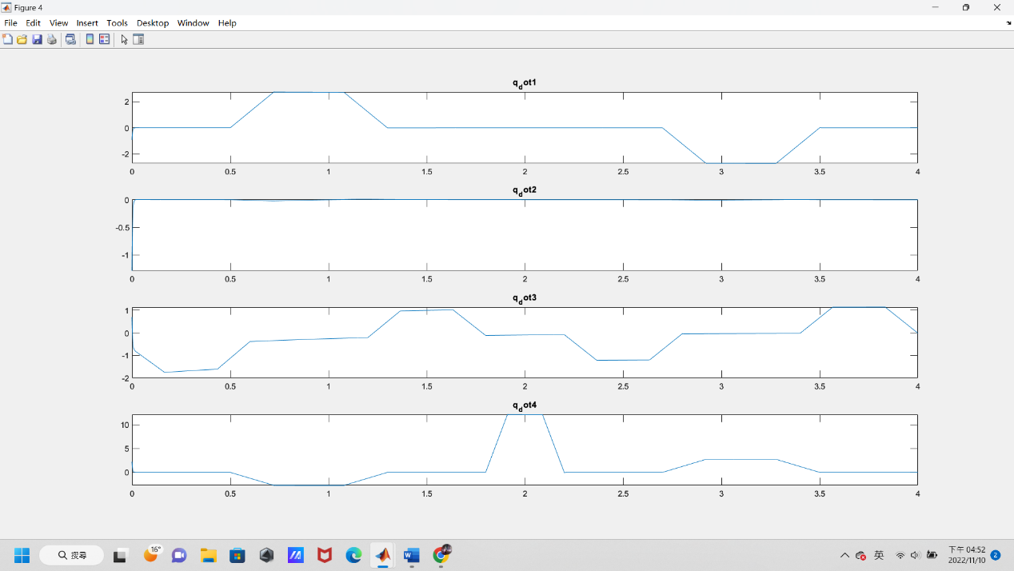

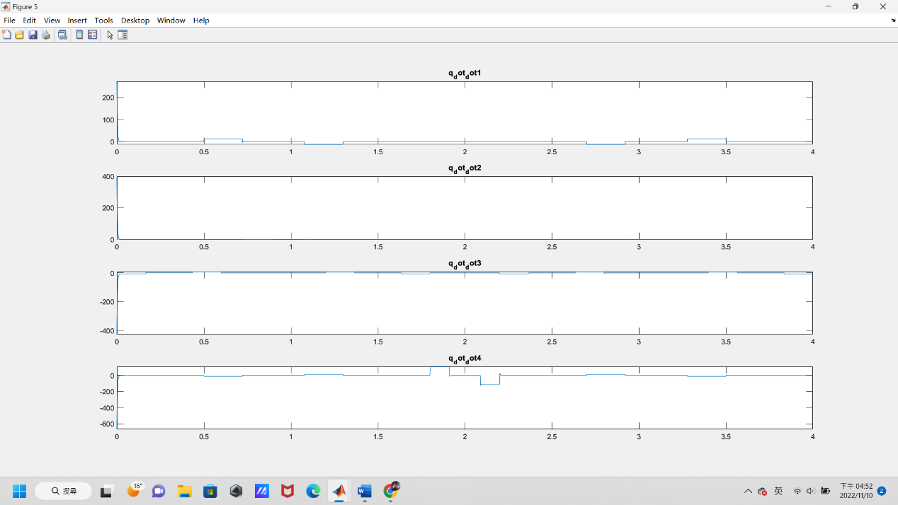

Part2:

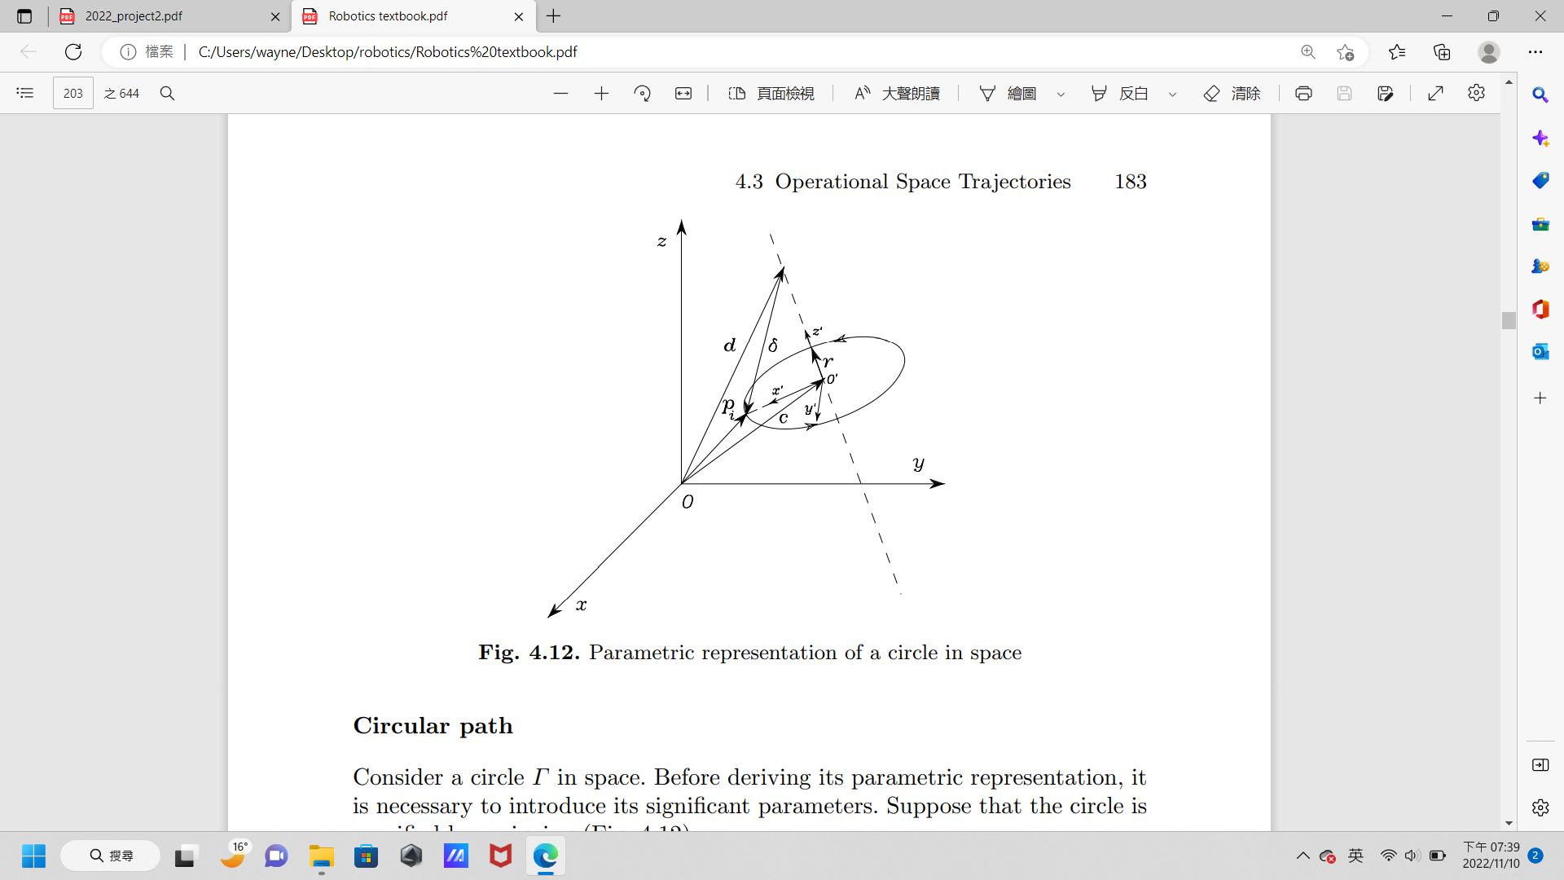

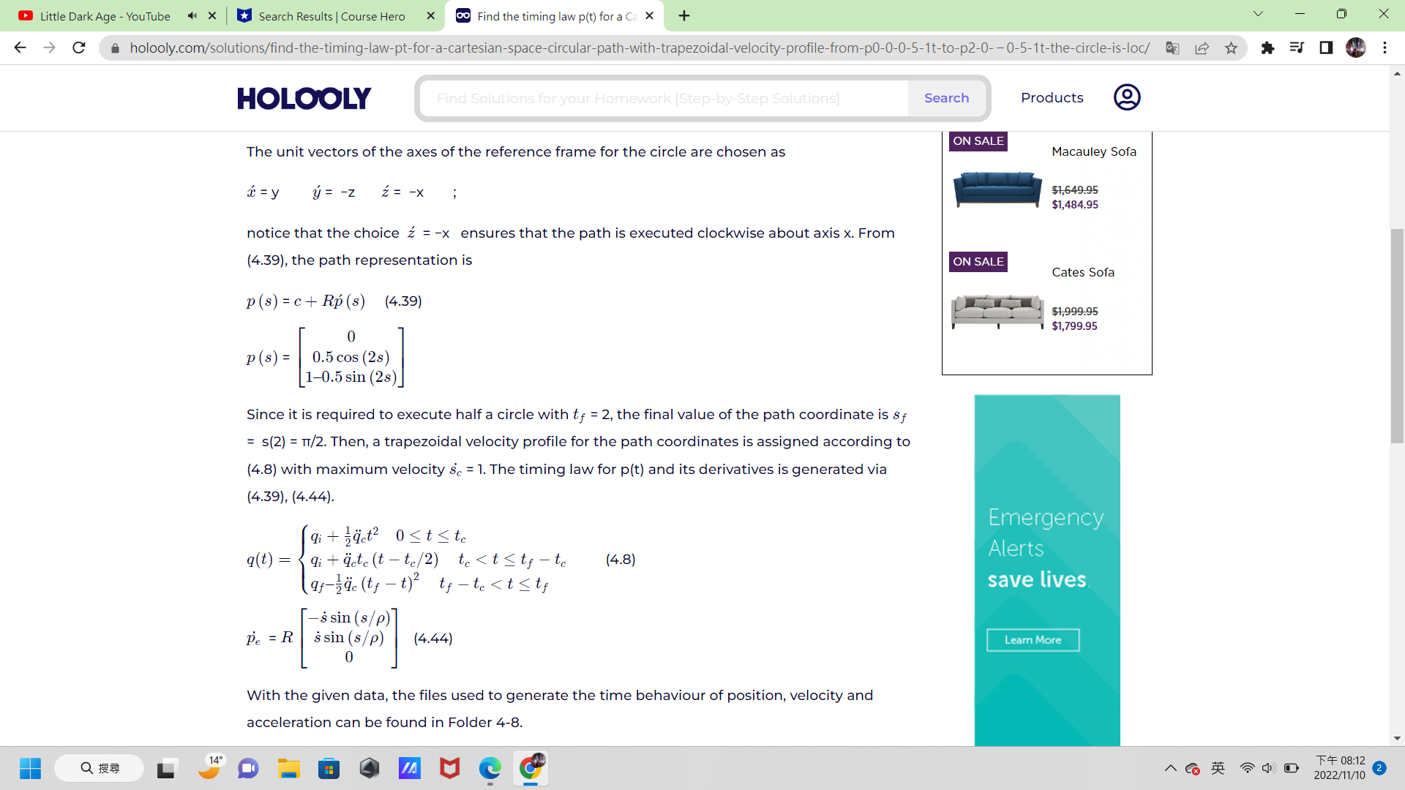

There should only have 3 rows in jacobian pseudo-inverse is given by:

according to the equation I think the Simulink scheme should look like below, this time I write my code inside Simulink function:

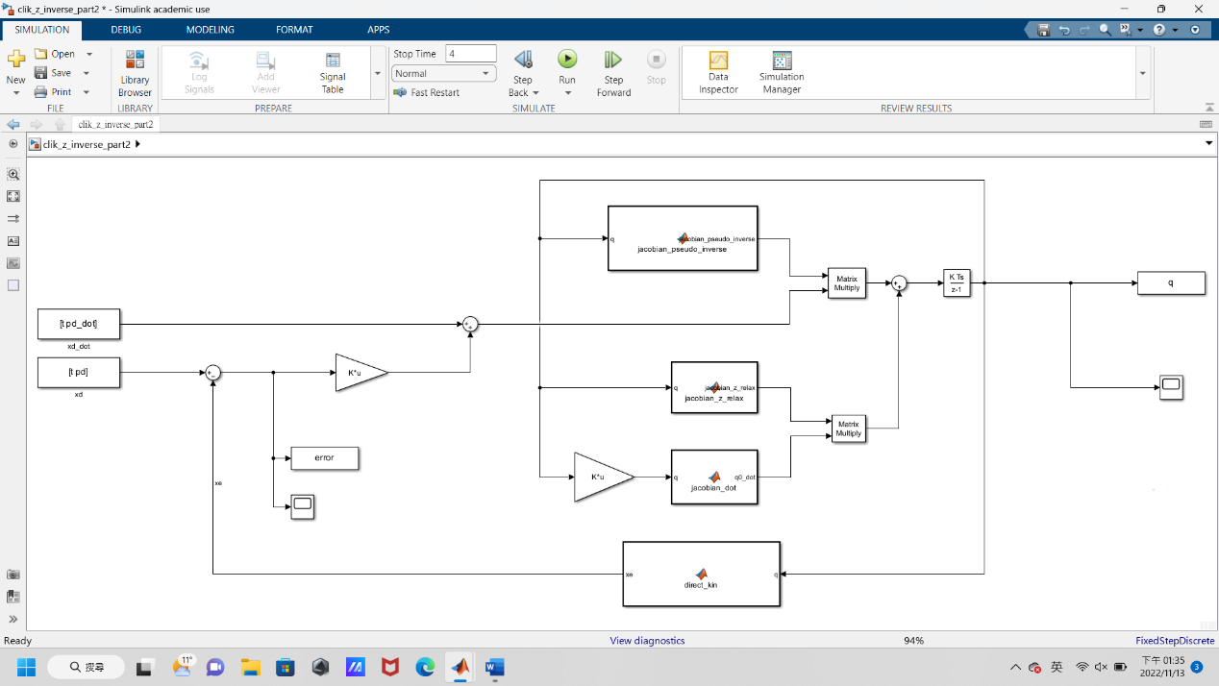

From the scope we can get error:

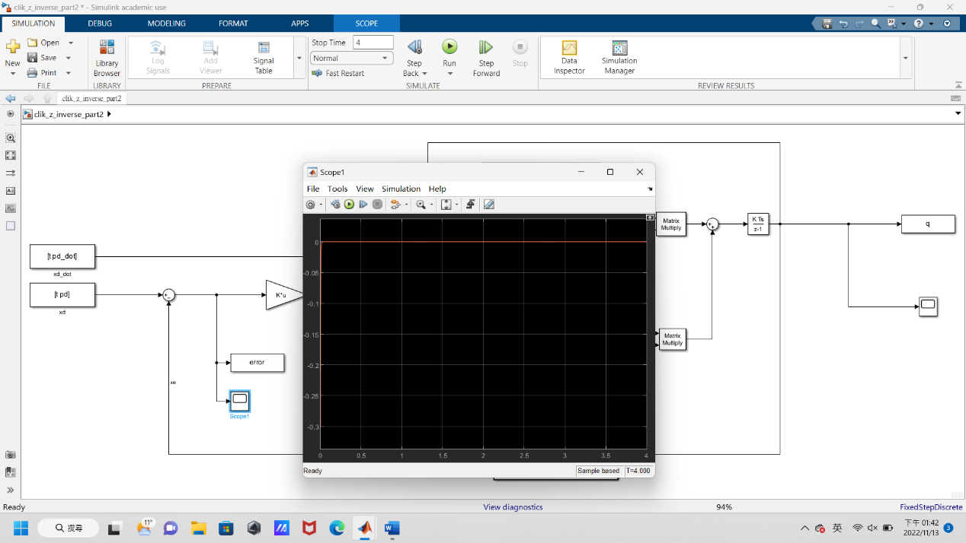

and q:

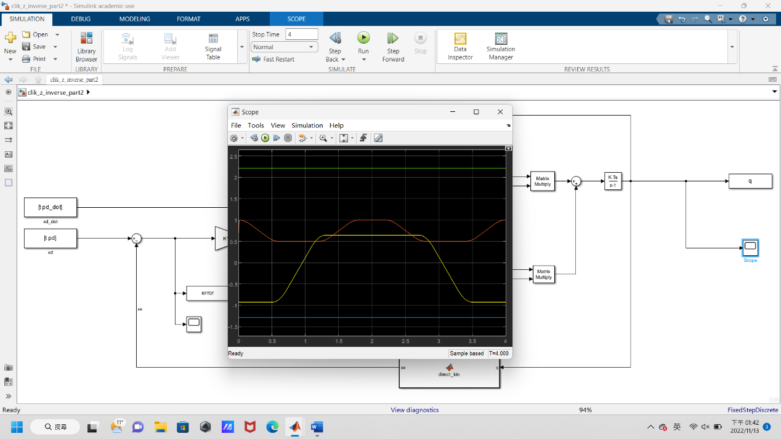

To get the Joint variables and errors in the operational space(please run the plot_output.m file):

Figure1: for theta1 theta2 d3 theta4

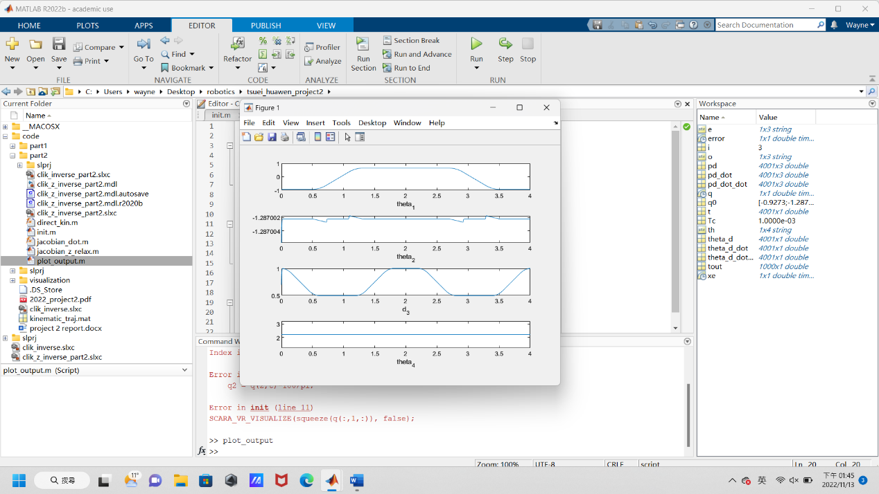

Figure2: for the error

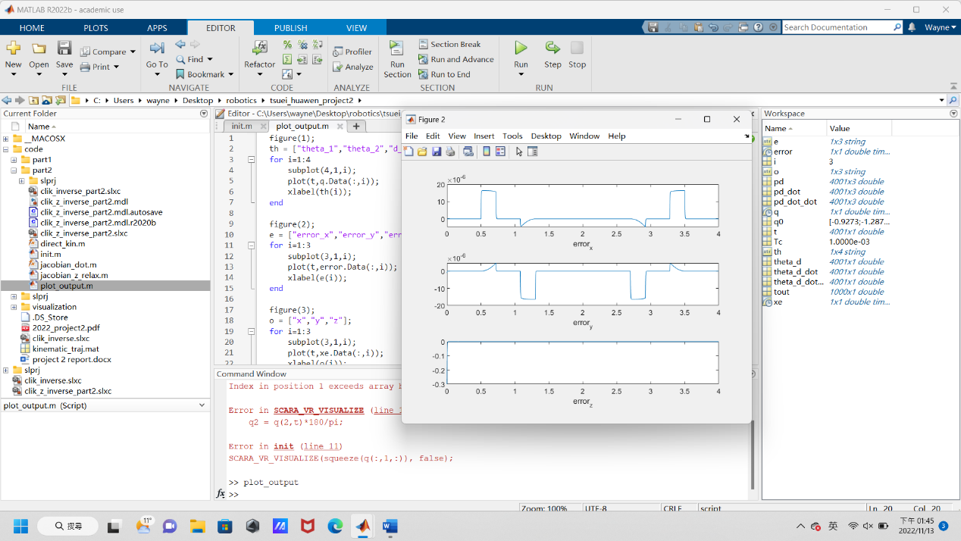

Figure3: for x y z

